Paper title in English (AVENIR, maximum 12 words)
Article subtitle

Title in Spanish

First name Last name (Avenir 11, justified, bold, single spacing)
Top title, University Affiliation, Country (Avenir 10, justified, bold, single spacing)

KEYWORDS | ABSTRACT
Keyword 1  Keyword 2  Keyword 3  Keyword 4  Keyword 5; | Abstract in English. Texto de un único párrafo, máximo 200 y 250 palabras, (Avenir 9, justificado e interlineado sencillo). El resumen debe contar con Metodología, Resultados, Discusión, Conclusiones.
PALABRAS CLAVE | RESUMEN
Palabra clave 1  Palabra clave 2  Palabra clave 3  Palabra clave 4  Palabra clave 5. | Resumen en español. Texto de un único párrafo, máximo 200 y 250 palabras, (Avenir 9, justificado e interlineado sencillo). El resumen debe contar con Metodología, Resultados, Discusión, Conclusiones.
Recibido: mm/dd/yyyy
Aceptado: mm/dd/yyyy

- Introduction
This is the first paragraph. Please use Avenir 11. The opening paragraph is not indented.
The text should be single-spaced, and spaces between paragraphs should only exist when using block quotes.
The introduction of a scientific article not only establishes the context and relevance of the study in its field, but also immerses the reader in the current state of knowledge. It offers a critical review of the relevant literature to identify research gaps and justify the need for the study. This section concludes with a detailed presentation of the objectives or hypotheses, clearly defining what the research seeks to discover or demonstrate and why it is significant.
- Methodology
The methodology presents a detailed analysis of the study design, explaining the selection and characteristics of the population and sample, along with the inclusion and exclusion criteria. It thoroughly describes the procedures and materials used for data collection, including the specific instruments or technologies employed. In addition, it details the data analysis methods applied, from statistical techniques to analysis software, ensuring that other researchers can replicate the study or evaluate its methodological rigor.
When tables and figures are included in the body of the article, place them after the paragraph in which they are described. When citing the source of information, include it at the bottom of the figure in a "source line." Tables and figures should be numbered and have a brief, descriptive title.
Table 1. (Avenir 11 bold, centered, single spacing, sequential numbering)
Table title. (Avenir 11, italics, left-aligned, single spacing).

 | Column title | Column title | Column title
Row title
Row title
Source(s): Author, Year of publication.

- Results
The results section organizes and presents the data obtained in a systematic manner, using tables, figures, and statistical analyses to illustrate the main findings. It focuses on presenting the results objectively, avoiding premature interpretations or conclusions. In addition, it highlights how these findings align with or differ from expectations based on the objectives or hypotheses proposed.

Figure 1. (Avenir 11, bold, centered, single spacing, sequential numbering).

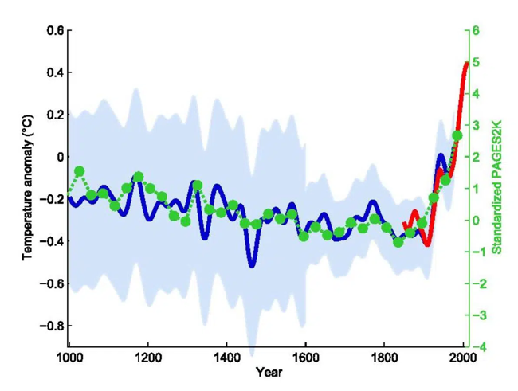
Figure title. (Avenir 11, centered, single spacing).

- Discussion
The discussion provides a detailed interpretation of the results, placing them in the context of existing knowledge. It analyzes the implications of the findings, how they contribute to or challenge previous theories, and their practical or theoretical relevance to the field. In addition, it critically addresses the limitations of the study, discussing how they might affect the interpretation of the results and suggesting areas for future research that could overcome these limitations or explore new questions arising from the study.

- Conclusions
Finally, the conclusion summarizes the key findings of the study, highlighting its contribution to the advancement of knowledge in the field. It proposes specific recommendations for practice, policy, or future research. This section highlights the added value of the study, encouraging reflection on possible future directions that research could take, based on the results and discussions presented.

References
Example of BOOKS: (authors separated by "," and the last one by "and")
Last name, A. A., Last name, B. B., and Last name, C. C. (Year). Book title in italics. Publisher.
Example of BOOK CHAPTER: (authors separated by ., and the last one by "and")
Last name, N. and Last name, N. (Year). Chapter title. In Initial name and Last name book author (eds.), Book title in italics (pp. xxx-xxx). Publisher.

Example of THESIS:
Last name, A. A. (Year). Title. (Doctoral Thesis). Name of institution, Location.

Example of JOURNALS: (authors separated by ., and the last one by "and")
Last name, A., Last name, B., and Last name, C. (Year). Article title. Publication title, volume(number), pp.-pp. https://doi.org/10.xxxxxx (if there is no DOI, the URL will be cited)

Example of WEB PAGES: (authors separated by ., and the last one by "and") Last names, B. B., Last names, C. C., and Last names, D. D. (Year). Title. www.xxxxxx.xxx

AUTHORS' CONTRIBUTIONS, FUNDING, AND ACKNOWLEDGMENTS

Contributions of authors:
Conceptualization: Last name Last name, First name.
Software: Last name, First name.
Validation: Last name, First name.
Methodology: Last name, First name and Last name, First name.
Data curation: Last name, First name.
Writing-Preparation of the original draft: Last Name, First Name.
Writing-Revision and Editing: Last Name, First Name.
Visualization: Last Name, First Name.
Supervision: Last Name, First Name.
Project management: Last name, First name.
All authors have read and accepted the published version of the manuscript: Last Name, First Name.
Funding: This research received/did not receive external funding.
Acknowledgments: if any.

Conflict of interest: if any.

